**VIKING PROJECT - CUSTOMER SATISFACTION SURVEY REPORT**

1. **Introduction.**

* Viking project was deployed and develop team began to get customers comment by using information from customer satisfaction survey.
* After review Viking project – customer satisfaction survey data, develop team begin to analyze and report result of survey.
* This document provide assessment and advice to help project team can improve their product quality, increase customer satisfaction.

1. **Customer satisfaction in each side**
2. The following picture will provide information about customer satisfaction through each side.

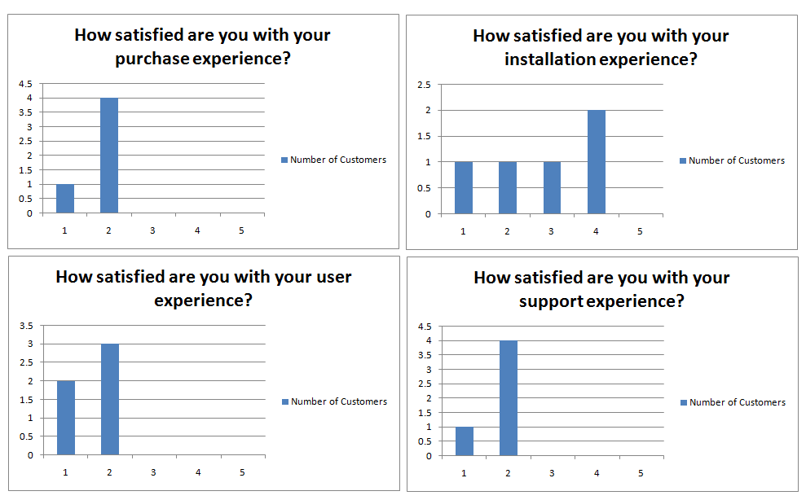

**Note**: customers are satisfy with purchase experience, user experience and support experience. In installation experience, customer’s behavior is not clear so cannot be assessed.

**Comment**: Customers maybe not satisfy with installation section in Viking software, develop team need to review that.

1. **Customer satisfaction in overall of Viking project.**

(tại vì chúng ta không có chỉ số quan trọng của đánh giá trong khảo sát nên không thể dùng CSI được, chúng ta sẽ dựa vào cái ảnh cuối cùng)

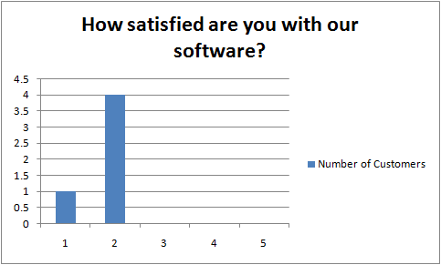

**Note**: In overall, customers are not fully satisfy with our software but in some case, the customer satisfaction is high.

1. **Assessment and advice.**
2. Customer are not fully satisfy with our software.
3. Should improve quality of installation section to increase customer satisfaction.
4. Some customer like our software but some others have trouble with compatibility between our software and their environment. Need to be resolved quickly.
5. Our customer hope, Viking software can be modified or add to it.
6. Still exist many problems that make software little hard to use.